Monday | Tuesday | Wednesday | Thursday | Friday
1 | Lunch & Learn  2 Concord Senior Center | 3 | 4 | 5
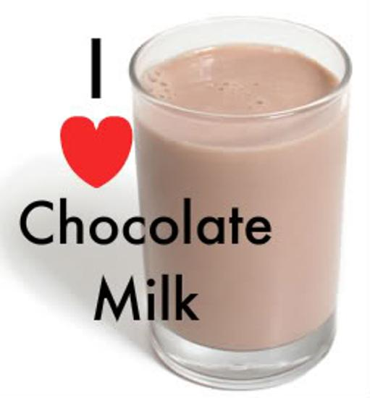  Rotini with Meatballs, Tomato Sauce & Mozzarella  Cauliflower  Seasoned Spinach  Fruit Cocktail  Chocolate Milk (776) | Cranberry Chicken Salad on a Bed of Fresh Salad Greens  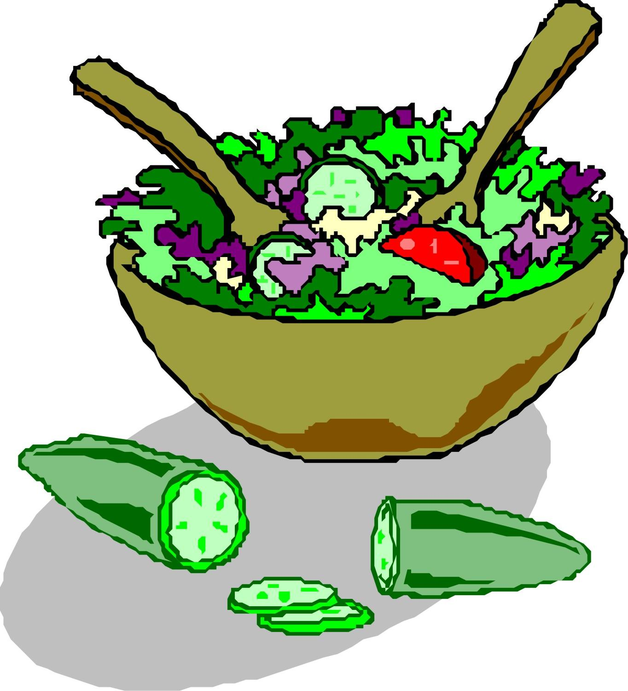  Dinner Roll  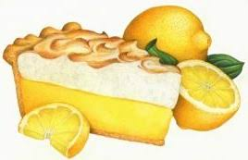  Lemon Meringue Pie  (851) | Turkey with Stuffing & Gravy Mashed Sweet Potatoes  Peas  Cranberry Gelatin Salad  Lorna Doones  (799) | Stuffed Pepper with Tomato Meatsauce  Mashed Potatoes  Normandy Mixed Vegetables  Dinner Roll  Chocolate Mousse (674) | Roast Pork with Cinnamon Apples  Mashed Potatoes  Carrots  Wheat Bread  Frosted Spice Cake (770)
8 | 9 ENTRÉE SALAD | 10 | 11 | 12 Flag Day Lunch
Turkey a la King  Mashed Potatoes  Carrots  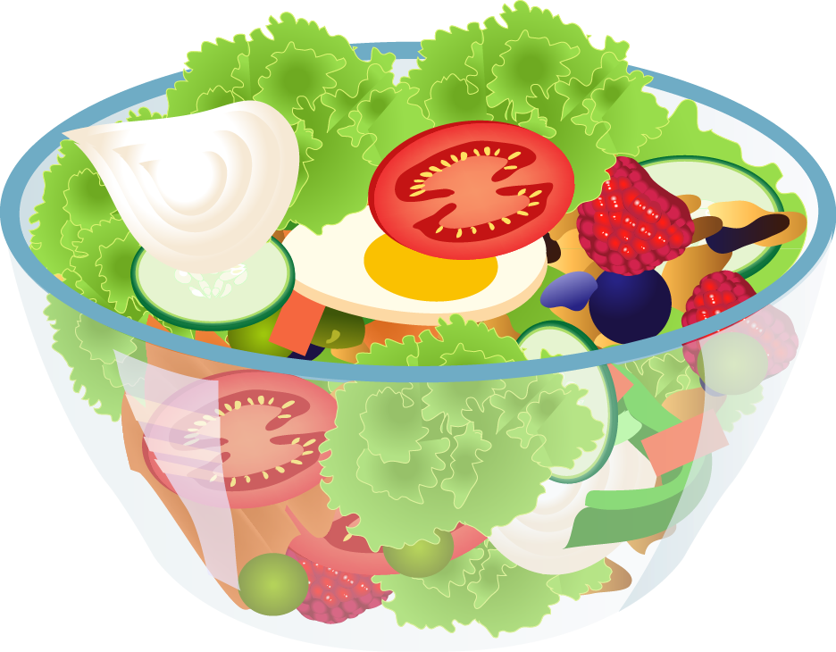  Biscuit  Chocolate Chip Cookies (742) | Julienne Salad with Classique Dressing  Rye Bread  Gelatin with Mandarin Oranges  (627) | Baked Salmon with Pineapple Salsa  Vegetable Rice Pilaf  Broccoli  Cornbread  Marinated Tomatoes  Baked Pear Crisp (859) | Chicken Parmesan with Penne Pasta & Tomato Sauce  Wax Beans  Chef Salad with Dressing  Tropical Fruit (615) | Steakhouse Burger with Gravy on a Wheat Roll  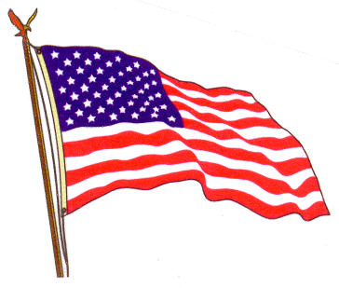  Lima Bean Bake  Fruit Punch  Potato Salad  Strawberry Shortcake with Whipped Topping (1057)
15 | 16 | 17 Father’s Day Lunch | 18 | 19 ENTRÉE SALAD
Italian Sausage with Peppers, Onions & Tomato Sauce on a Bun  Roasted Red Potatoes  Mixed Vegetables  Pineapple (597) | Vegetable Lasagna with Cream Sauce  Italian Green Beans  Cauliflower  Dinner Roll  Frosted Cherry Cake (828) | Breaded Chicken Drumsticks  Au Gratin Potatoes  Peas  Wheat Dinner Roll  Chef Salad with Dressing  Chocolate Cream Pie (1167) | Meatloaf with Gravy  Mashed Potatoes  Broccoli  White Bread  Vanilla Mousse (822) | Tuna Macaroni Salad with Fresh Salad Greens  Whole-grain Crackers  Fresh Apple  Chocolate Milk  (780)
22 | 23 Welcome Summer! | 24 | 25 | 26
BBQ Pork Ribette on a Bun  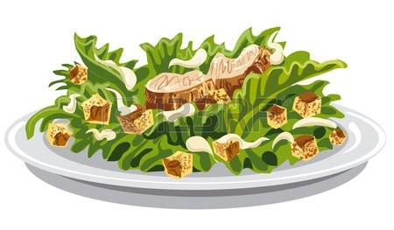  Cheesy Mashed Potatoes  Seasoned Mixed Greens  Glazed Lemon Cake  (950) | Chicken, Mandarin Orange & Sunflower Salad with Fresh Spinach Greens  Whole-grain Crackers  Ice Cream Sandwich (713) | Beef Macaroni Casserole  California Mixed Vegetables  Corn  Rye Bread  Fruit Compote  Chocolate Milk (847) | Roasted Turkey Breast with Stuffing & Gravy  Mashed Potatoes  Peas & Carrots  Cranberry Gelatin Salad  Oatmeal Raisin Cookies (885) | Breaded Fish with Tartar Sauce on a Whole Wheat Bun  Macaroni & Cheese  Italian Green Beans  Coleslaw  Mandarin Oranges (924)
29 | 30 | 1 | 2 Independence Day Lunch | 3 No Meals Served
Cheese Ravioli with Meatsauce  Peas  Seasoned Squash with Peppers  Italian Bread  Peaches  Chocolate Milk (813) | Quarter Chicken with Gravy & White Rice  Carrots  Cauliflower  Sugar Cookies (780) | Roast Beef with Gravy & Horseradish  Sweet Potatoes  Savory Cabbage  Rye Bread  Frosted Marble Cake (811) | Hot Dog with Baked Beans & Mustard on a Bun  Corn-on-the-Cob  Fruit Punch  Vegetable Pasta Salad  Cherry Pie with Whipped Topping (1098)

