Monday | Tuesday | Wednesday | Thursday | Friday
27 | 28 | 29 ENTRÉE SALAD | 30 | 1
Chicken Vegetable Casserole with a Biscuit  Broccoli  Cinnamon Streusel Cake  (739) | Hot Dog with Baked Beans & Ketchup on a Bun  Roasted Red Potatoes  Carrots  Pineapple  (676) | 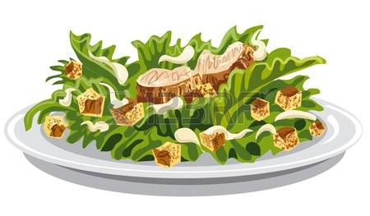  Grilled Chicken Breast with Garden Greens & Ranch Dressing  Rye Bread  Fresh Apple  Chocolate Milk (774) | Lasagna Roll with Meatsauce  California Mixed Vegetables  Grape Juice  Dinner Roll  Lemon Bavarian (757) | Meatloaf with Swiss Gravy  Mashed Potatoes  Peas with Pearl Onions  Wheat Bread  Chocolate Chip Cookies (779)
4 | 5 | 6 Mother’s Day Lunch | 7 ENTRÉE SALAD | 8
Cheese Omelet with Peppers, Onions, Tomatoes & Cheese Sauce  Tater Tots  Raisin Bread  Fruit Compote  (777) | Boneless Chicken Breast with Gravy  Mashed Sweet Potatoes  Peas  Dinner Roll  Cinnamon Pear Crisp  (687) | Breaded Pork Chop with Gravy  Mashed Potatoes with Chives  Carrots  Chef Salad with Dressing  Cheesecake with Strawberry Topping (946) | Cranberry Chicken Salad on a Bed of Fresh Salad Greens  Whole Wheat Dinner Roll  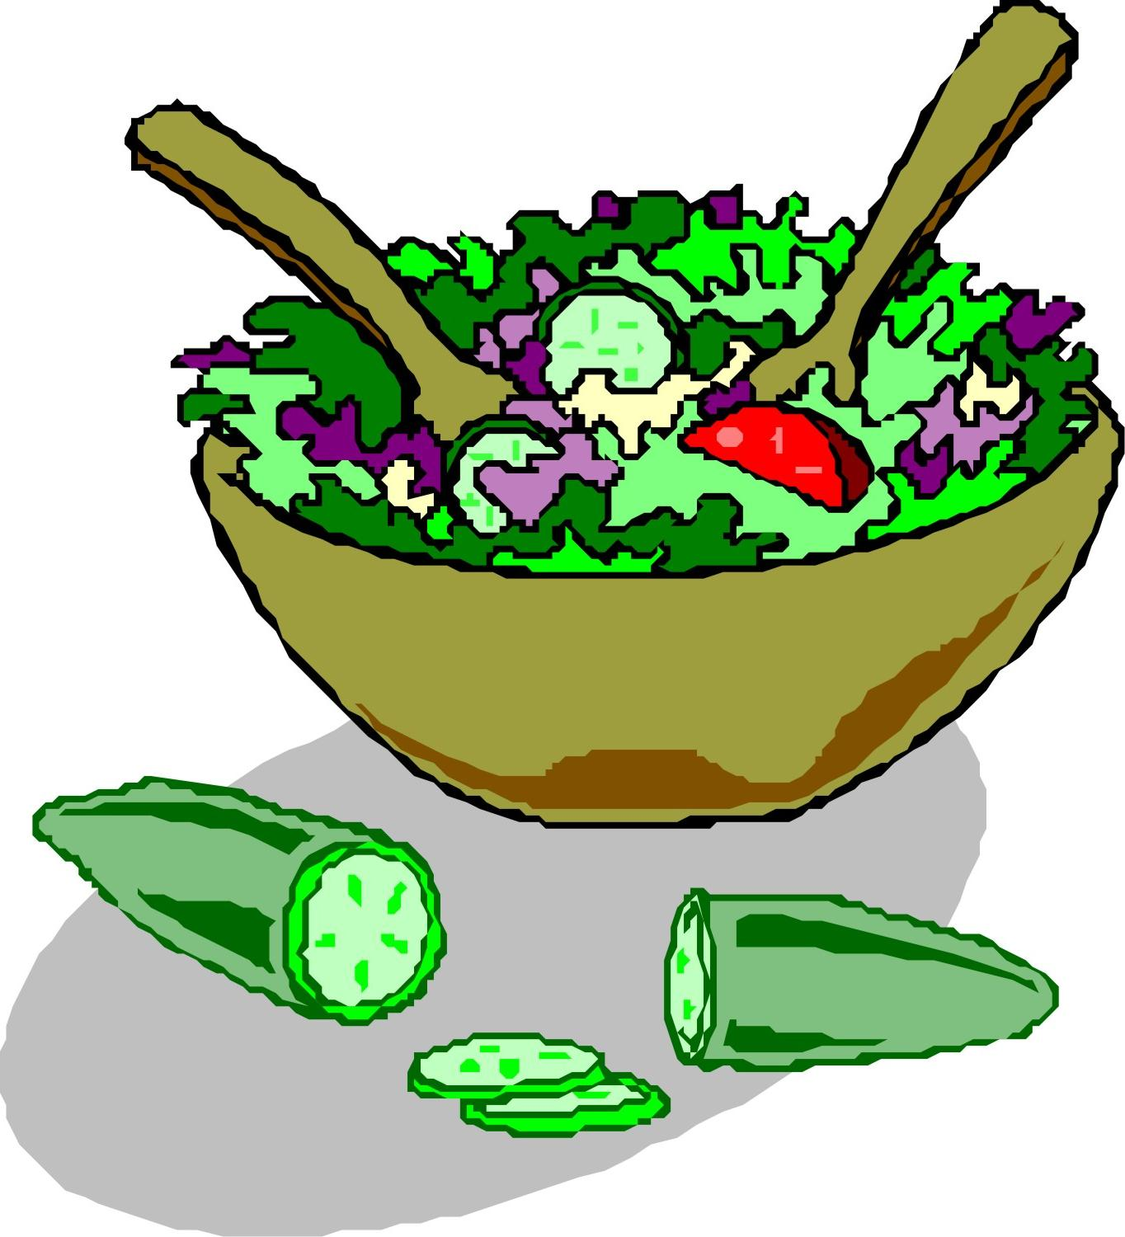  Pineapple & Mandarin Oranges  (658) | Teriyaki Beef on a Bed of Rice  Oriental Vegetables  Pineapple Juice  Fresh Apple  Chocolate Milk (662)
11 | 12 | 13 | 14 ENTRÉE SALAD | 15 Lunch & Learn  West Seneca Senior Center
Breaded Chicken Breast with Herb-seasoned Gravy  Fresh Roasted Red Potatoes  French Bean Medley  Dinner Roll  Fresh Orange (543) | Stuffed Shells with Tomato Meatsauce & Mozzarella  Seasoned Spinach with Mushrooms  Cauliflower  Italian Bread  Sugar Cookies (841) | BBQ Pork Ribette  Scalloped Potatoes  Peas with Red Pepper  Dinner Roll  Chocolate Bavarian (865) | Tuna Macaroni Salad on a Bed of Fresh Salad Greens  Whole-grain Crackers  Strawberry Gelatin with Mandarin Oranges  (671) | Breaded Chicken Drumsticks  Macaroni & Cheese  California Mixed Vegetables  Whole Wheat Dinner Roll  Chef Salad with Dressing  Chocolate Éclair (961)
18 | 19 | 20 | 21 | 22 Memorial Day Lunch
Ham Steak with Pineapple Topping  Sweet Potatoes  Creamy Dill Cabbage  Whole Wheat Dinner Roll  Shortbread Cookies (692) | Beef Stew with a Biscuit  Brussels Sprouts  Cinnamon Applesauce  Chocolate Milk  (675) | Cheese Tortellini with Chicken & Cream Sauce  Carrots  Italian Vegetables  Italian Bread  Strawberry Bavarian (574) | Turkey with Stuffing & Gravy  Garlic Mashed Potatoes  Green Bean Casserole  Cranberry Gelatin Salad  Fresh Apple  (761) | BBQ Chicken Quarter  Corn-on-the-Cob  Broccoli & Cauliflower  Macaroni Salad  Dinner Roll  Strawberry Swirl Ice Cream (1013)
25 No Meals Served | 26 | 27 | 28 ENTRÉE SALAD | 29
 | Sloppy Joe on Wheat Roll  Fresh Red Potatoes  California Blend Vegetables  Tropical Fruit  (658) | Sliced Roast Beef with Horseradish & Gravy  Cheesy Mashed Potatoes  Carrots  Rye Bread  Fresh Banana  (818) | Chicken Caesar Salad with Caesar Dressing  Whole Wheat Dinner Roll  Mandarin Oranges  (810) | Beer Battered Fish with Tartar Sauce  German Potato Salad  Mixed Vegetables  Coleslaw  Cornbread  Ambrosia (837)

